Development of an AI-based Surrogate Model for Real-Time Prediction of Stress and Deformation in Parametric CAE Systems.

- Abstract
This project is to develop an AI surrogate model capable of predicting equivalent (Von Mises) stress and total deformation of a product in the form of a 3D model. It is done repeatedly for different parameters without performing computationally expensive finite element analysis (FEA). The study consists of a two-plate geometry (L-shape bracket) where there is a horizontal lower plate (LP) and a vertical upper plate (UP). Geometric parameters, including plate dimensions, fillet radius, and hole radius, are varied to generate a simulation dataset. Fixed support is applied to the hole on the upper plate while an external load is applied through the hole on the lower plate. Two machine learning models are investigated: Linear Regression for deformation prediction and Random Forest Regression for stress prediction. The Mean Absolute Error (MAE) is used to assess a model's performance. The results indicate that deformation has an approximately linear relationship with the input parameters, making Linear Regression a very suitable choice. Conversely, stress is nonlinear due to stress concentration around the fillet and hole, where Random Forest demonstrated better predictions. The proposed surrogate model can substantially decrease computational time while maintaining satisfactory prediction accuracy, thus showing its potential for rapid design evaluation and optimisation.

- Introduction
(Finite Element Analysis) FEA is widely used in Mechanical Engineering to evaluate structural performance before physical manufacturing. However, performing a complete FEA for each design over many design iterations becomes computationally expensive during optimisation. AI provides an alternative solution to this using surrogate modelling. Machine learning is used to learn the relationship between design parameters and structural responses from simulation data. The trained model could predict these data at much higher speeds, making them attractive for real-time engineering applications. This project aims to develop machine learning models for predicting deformation and stress using a dataset generated from parametric FEA simulations.

- Geometry & Modelling
The geometry consists of 2 plates forming an L-shape bracket. The lower plate (LP) represents the horizontal bottom plate, and the upper plate (UP) is the plate that’s positioned vertically. The upper plate (UP) contains a fixed hole, while the lower plate (LP) contains a single loading hole through which the external force(1000N) is applied. Eight geometric parameters are varied: LP-L, LP-W, LP-T, UP-L, UP-W, UP-T, fillet radius, and hole radius (LP). These variables define the design space used for dataset generation.
(L-length, W- width, T-thickness).
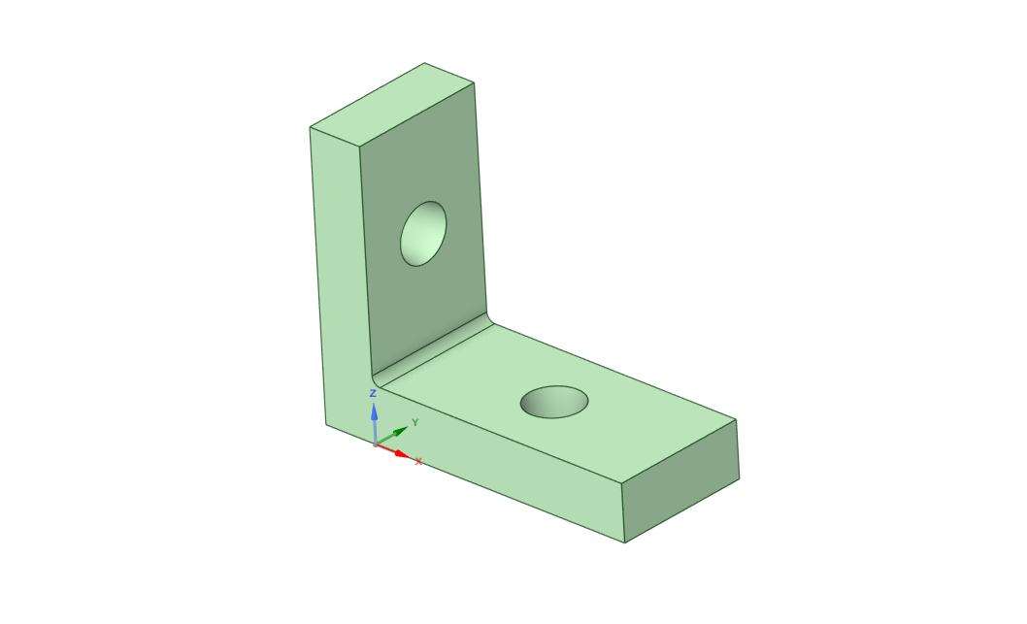
Figure 1: Parametric 3D model done using SpaceClaim.
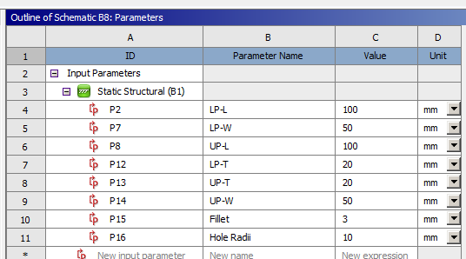
Figure 2: Parameters

- Finite Element Analysis
Finite Element Simulations were performed for each parameter combination. The upper plate hole was fixed while the lower plate hole had an external force of 1000N applied. A sufficiently refined mesh was used to capture stress concentration around the hole and fillet. The outputs extracted from every simulation were Equivalent (Von Mises) Stress and Total Deformation.

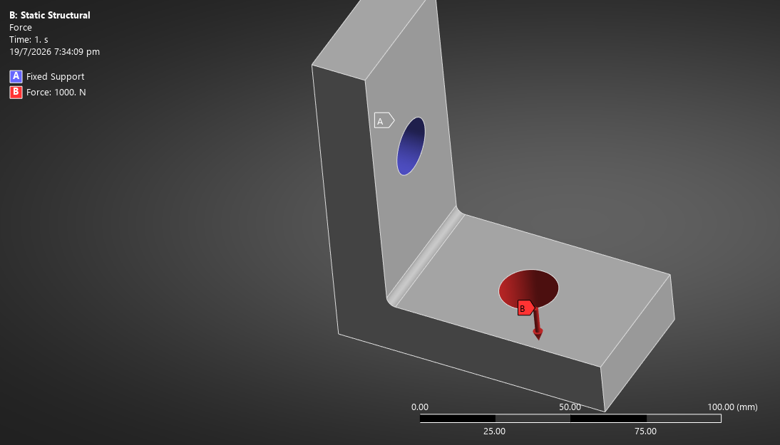Figure 3: Boundary Conditions 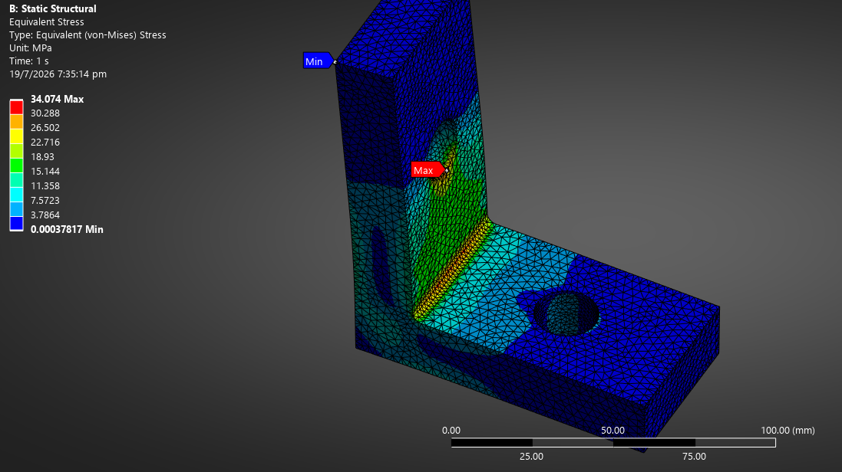
Figure 4: Stress distribution
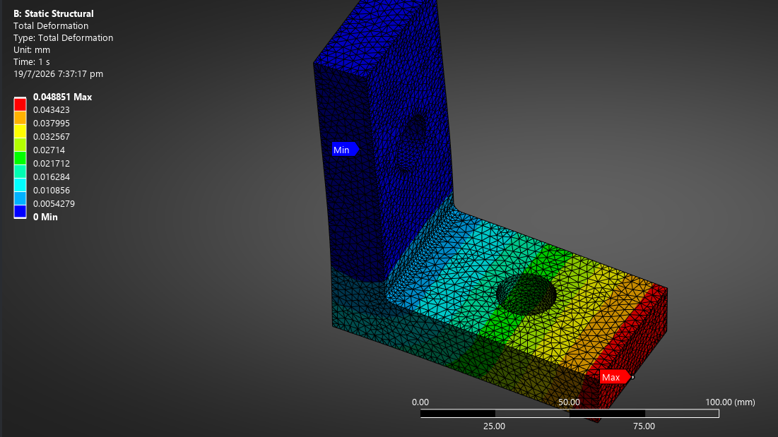 Figure 5: Deformation distribution

- Dataset Generation
A parametric simulation workflow was made to generate multiple design configurations. Each row produces eight geometric parameters coupled with the stress and deformation values as the output values. This dataset forms the training and testing data for the machine learning models. The automated approach ensured consistent simulation settings while covering a broad design space.
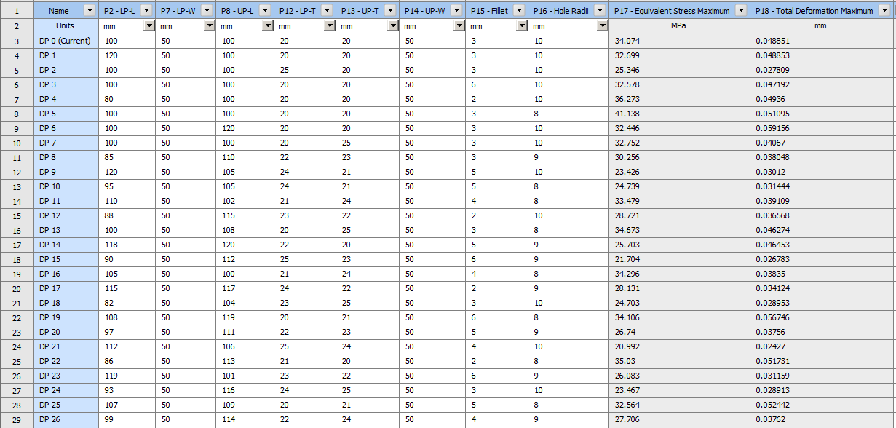
Figure 6: Dataset Generation
- Machine Learning Methodology
Two machine learning methods, linear regression and random forest, were used to obtain a more accurate model. Based on the results, the linear regression produced better accuracy for deformation. This is due to the deformation changing proportionally with the geometry under constant loading conditions, thus giving a better accuracy. Random Forest was selected for stress prediction. This is due to local stress concentration around holes and fillets, introducing nonlinear relationships. Model performance was evaluated using Mean Absolute Error (MAE). Predicted-versus-Actual graphs were generated to evaluate predictive performance. A coefficient plot was used to interpret Linear Regression, and feature importance analysis was used for Random Forest.
The coefficient plot in Figure 8 obtained from the linear regression model shows the influence of each geometric parameter on structural deformation. Parameters with large absolute coefficient values have a greater influence on the predicted deformation. Positive coefficients indicate that an increase in the parameter leads to higher deformation, while negative coefficients indicate a reduction in deformation. This provides interpretability to the model and helps identify the most critical design variables affecting structural performance.
The feature importance plot is done for the random forest model to predict the stress based on the contribution of each parameter. Random Forest captures complex nonlinear interactions between variables, making it more suitable for stress prediction. Figure 10 shows that certain parameters influence the stress distribution. This is consistent with engineering principles, where stress concentrations are significantly affected by geometry variations, particularly near discontinuities such as holes and fillets. Hence, this plot provides insights into which design parameter plays a key role in stress behaviour and design optimisation can be done based on that information.

- Results
MAE (Mean Absolute Error) | Linear Regression | Random Forest
Stress (Mpa) | 1.48 | 1.36
Deformation(mm) | 0.00107 | 0.00266
Table 1
R-squared stress value for LR: 0.74
R-squared deformation value for LR: 0.98
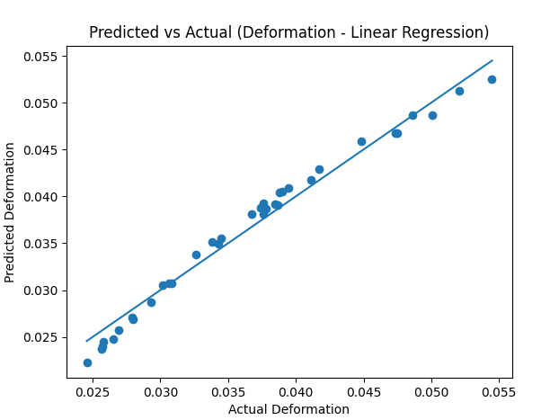
Figure 7: Predicted vs Actual deformation
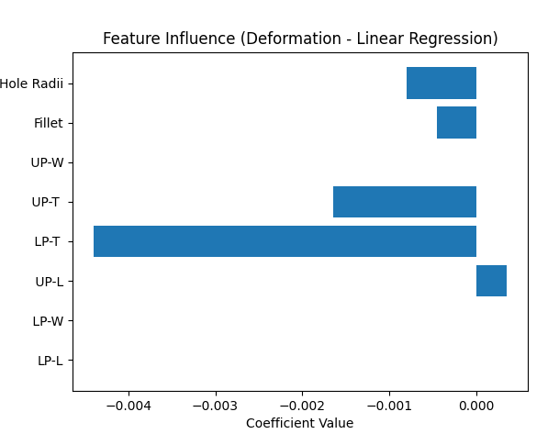
Figure 8: Linear regression coefficients
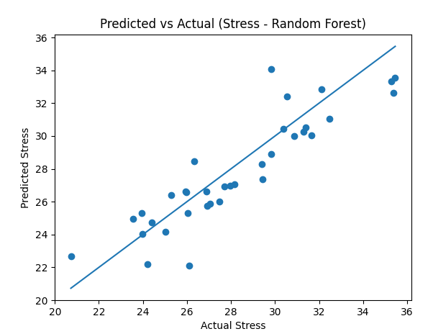
Figure 9: Predicted vs Actual Stress
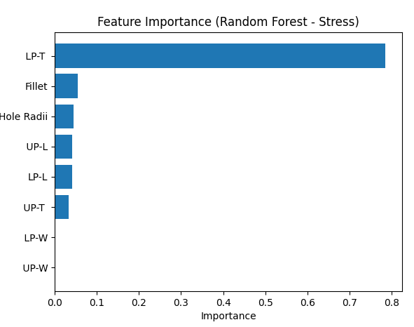
Figure 10: Random Forest Feature Importance
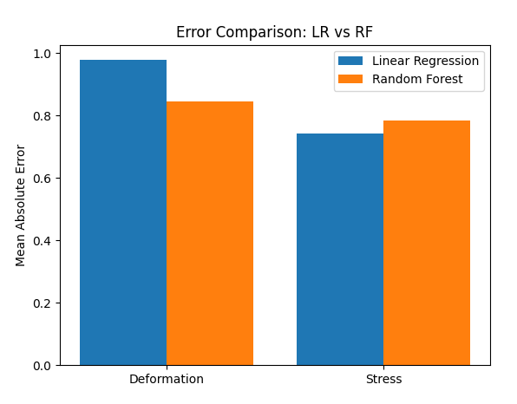
Figure 11: Error Comparison Plot

- Discussion
The linear regression model

